Razor Pages

1. Create a welcome page:

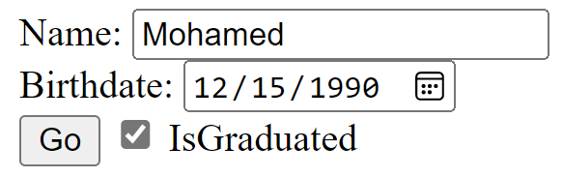



2. Greeting Card Maker:
a. Background design [provided in the folder]
b. There is a static picture for every greeting type [provided in folder]. (note: the checkbox is an option given to control the picture visibility)
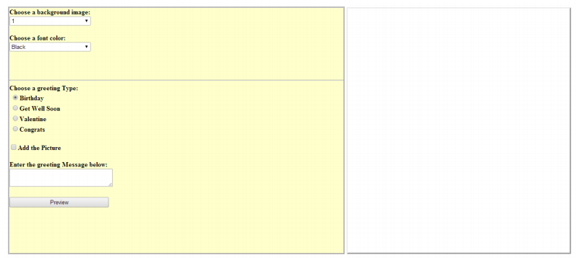

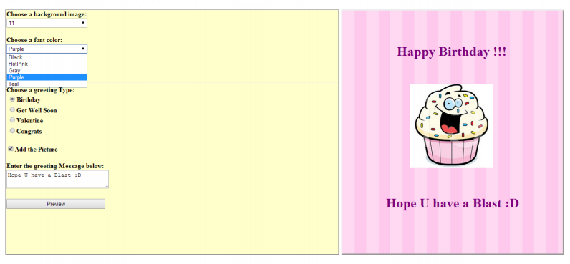

3- try to search for a “Professional template design”, then create a Layout template for your pages, apply it on all the pages (using _PageStart)

